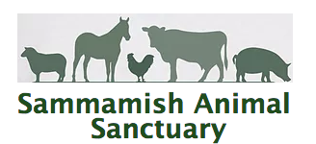

Assumption of Risk and Release Form

_____ I am over the age of 18 and am competent to execute this release.

______ I am the parent or guardian of __________________________________ (participant),
who is under the age of 18.

I, or my child, seek to participate in activities working around and with animals at Sammamish Animal Sanctuary located at 20727 SE 24th Street in Sammamish, Washington. I understand that my or my child’s participation in these activities are allowed by signing this Assumption of Risk and Release. All of the entities that own, operate, and maintain the property for the animal sanctuary will not be held liable or assume any risk of personal injury, death, property damage or other injuries arising in connection with my participation or my child’s participation in any activities associated with Sammamish Animal Sanctuary.

I understand that the farm activities, including working around animals, is inherently dangerous because farm animals, especially horses, can be unpredictable and can react to sounds, sudden movements and unfamiliar objects. I assume any and all risk including injury, damage or death associated with my or my child’s participation in all activities associated with Sammamish Animal Sanctuary and the Sanctuary’s owners.

I have carefully read this release and fully understand its contents. I am aware that this is a release of liability between Sammamish Animal Sanctuary, it’s owners and myself. I have signed of my own free will.

_______________________________________________________ (Signature) ________ Date

________________________________________________________(Print Name) _______Date

